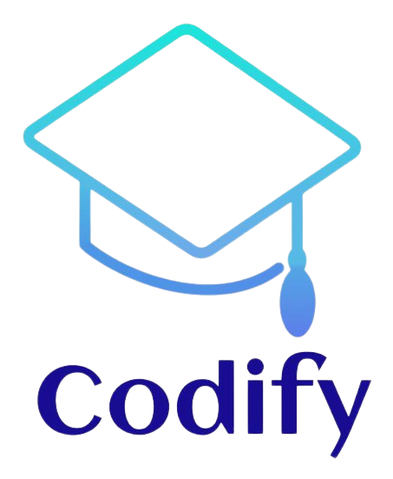

**CODIFY QA DOCUMENTATION**

**Contents**

Contents

1.Introduction 3

2.Enter and Exit 3

3.Our project goal 4

4.Tasks 4

5.Testing 5

1.Introduction

**Hi, we are Codify, and we pride ourselves on being the top app for testing your skills across various school subjects. Codify have the best security system, ensuring that nobody can access your account without authorization. Simply download the app and put your skills to the test!**

2.Enter and Exit

**When you enter the app, your access to the application is provided as you begin your first test.**

**When you exit the app, the tests are completed successfully and there are no errors.**

3.Our project goal

**Our main goal with this application is to create an experience similar to Shkolo. We provide you with a platform where you can create an account and solve your exams.**

4.Tasks

**The tasks that needed to be completed are testing every aspect of the app, creating various test cases, and creating the QA documentation.**



5.Testing

**The primary elements requiring testing are the login and registration menus, as well as all the different subjects and their respective attempts. Other things also as, errors and app functions should be thoroughly tested.**

**To document the tests, Excel tables were used to outline the various cases and Word for the test plan. Resources such as Excel for the tables, Word for the test plan, and GitHub for tracking different issues were utilized.**

**.**



**CODIFY QA PRESENTATION**